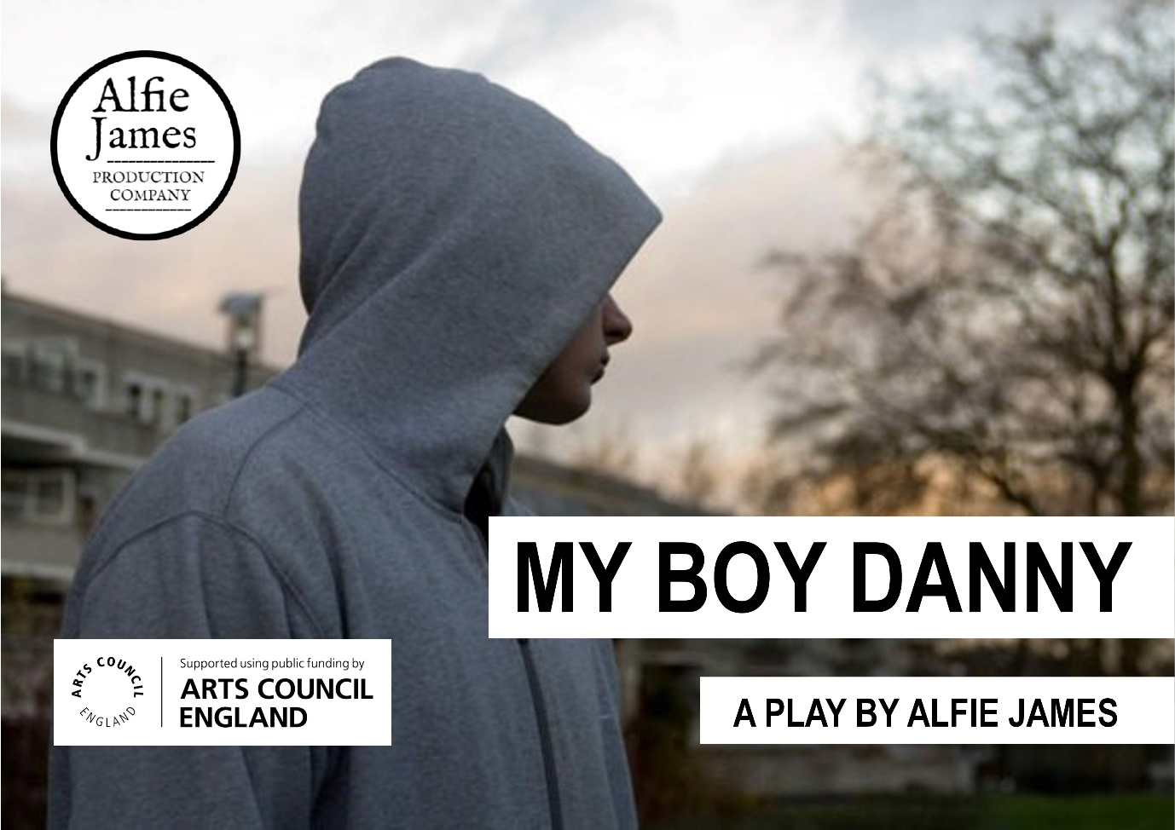

A Chat With My Boy Danny Playwright Alfie James

By Monica Yell | 11th Sep 2020 |
After listening to the radio play of My Boy Danny and writing up my review, I had a (virtual) sit down with its award-winning playwright and director Alfie James to chat about making theatre in lockdown, and this play in particular. Here are the highlights of our conversation:
Before we get started on how and why you produced an audio recording of My Boy Danny for YouTube, would you mind introducing what the play is about?
On one level the play is about people affected by gang crime, and the societal disillusionment which leads to it. But for me, the heart of My Boy Danny is also a love story. I use monologues a lot to allow characters to reminisce about their memories with the eponymous Danny, really trying to hone in on and celebrate the magical moments in relationships, which might not seem so special at the time. It’s about treasuring those memories after a person has died, even during the grieving process as a way to stay connected to who they were and what they meant to you.
What have been the highlights of your career, before My Boy Danny?
I’ve been writing plays for about thirty years now, starting off locally in Essex and building up from there. Theatre’s ability to act as a tool for exploring social change has led me to projects dealing with mental health, projects in conversation with the elderly, projects addressing our heritage. I never dreamed that I would have plays performed in London until a few years ago, when working on a series of pieces about the first world war. Collaborating with museums turned into a short sold-out run at the Albany Theatre (Deptford) which turned into a night upstairs at the Arts Theatre in the West End. You might not believe it, especially since I certainly didn’t at the time, but an audience member literally approached me to offer a fully funded week of performances at the Tristan Bates Theatre. My jaw dropped. It was such a joy to contribute to the fantastic theatre industry in London.
How did My Boy Danny end up online in this format?
One of the scary things about lockdown has been the complete standstill the world has come to, especially in live arts. I’ve kept having to remind those friends of mine who have lost jobs and are feeling downhearted that there’s going to be a turnaround. The theatres are slowly opening already, and even those that aren’t are sending out very encouraging messages, promising that they’ll get there when the time is right. We all just need to hang in there. In the meantime, making an audio version of My Boy Danny available online was a way for us to help keep theatre going. The brilliant cast who were meant to be performing it on stage this year had cornered me on Zoom and convinced me that it would be something worth doing. It definitely was, because I think everyone involved became more skilled as a result of dealing with all the new challenges we encountered. The first challenge was to adapt the script into a radio play, which meant I had to add lines explaining what would have been the action on stage, without making it seem unnatural. And then directing the actors (Kitty Whitley, Ben Kinsman and Atarah) posed another set of challenges because acting is usually so reliant on physicality. They were phenomenal at dealing with the handicap of only using their voices, and I found myself adapting to giving directions like “I think that line needs more sarcasm,” or “more emotion” a lot in order to best suit the medium. Besides which, I’m no techie, so it wasn’t a small task to learn the practical skills needed to produce the recording either. Sometimes we were halfway through scenes before realising someone hasn’t got their microphone on. Sometimes I was attempting to offer notes to the actors whilst appearing upside down on screen. There were a lot of laughs, but we got there in the end.
What has the response been like?
We’ve found the play has been popular. It has definitely reached a much larger audience than it would have been able to in a studio auditorium, not to mention being comprised of very different people, and we’ve had some lovely feedback from them. It’s made us very proud to hear from those who really enjoyed the play and connected with the characters. A journalist even got in touch because of his appreciation of how sensitively and honestly we were discussing gang violence, something he had suffered real-life experiences of. Another woman, a stranger living right in the middle of a council estate, said we had hit the nail on the head. Someone coming forward and standing with you and your message like that when you put it out into the world is always encouraging. Stuff like that really acts as a confirmation that what you’re doing is valuable, so I try to show my gratitude by replying to comments, something I wouldn’t be able to do were the play not online.
You mentioned that people connected a lot with the characters, and their moral ambiguity was something which had struck me when I was listening to My Boy Danny. Is this something you thought about during the writing process?
Trying to represent real people in real situations has been integral to the project since its beginning. I had wanted to join the national conversation about gang and knife crime a few years ago, when it really came to prominence, but was wary about creating a play which was stereotypical or copycat. So even drafting the ideas which came to me then, knowing it would be while before I started writing in earnest, the realness of the characters was important. There aren’t any heroes or villains in My Boy Danny. Yes, there are mentions of a murderer who we never meet, but the presence of his conflicted girlfriend hopefully demonstrates complexity and humanity. The mum too – she isn’t the greatest mum in the world. She’s just normal, and she knows that her son isn’t perfect either. No one is simplified down to a good or evil force in the story. Everyone is torn. That way it’s much more possible to humanise both gang violence and homophobic hate crime, which I think is really valuable. Plays like this can change statistics back into people, so we don’t dismiss them when we hear about them on the news. These are real issues which do affect real people – I experienced hate crime myself when I came out, so I really feel that raising awareness in this way is vital. As a result, it has been so exciting to share the play online with anyone who is interested in listening to it.
If you are interested in listening to My Boy Danny, you can find it here. I’d highly recommend it, but for more convincing you can check out my review here. Otherwise, Alfie tells me the company is looking at performing it live at Brighton Fringe next year, so if you’re sick of the digital dimension (understandable) then you can keep an eye out for it there.

From: https://broadwaybaby.com/features/a-chat-with-my-boy-danny-playwright-alfie-james/2242

